**AzureML Integration With Bot Framework**

# What is Microsoft Bot Framework?

**The Microsoft Bot Framework** enables organizations to build intelligent agents, known as Bots.

Bots let users interact with intelligent solutions as they are conversing with another person, and interactions can take many forms, **from text/SMS to Office365 mail to Skype and Slack**. The Framework provides developers with a developer portal and SDK to build Bots, a Bot Connector service to connect to social channels such as Twitter and Slack, and a Bot Directory to discover and use existing bots. Bots can be created locally using Bot Builder SDK or in Azure by creating Bot App.

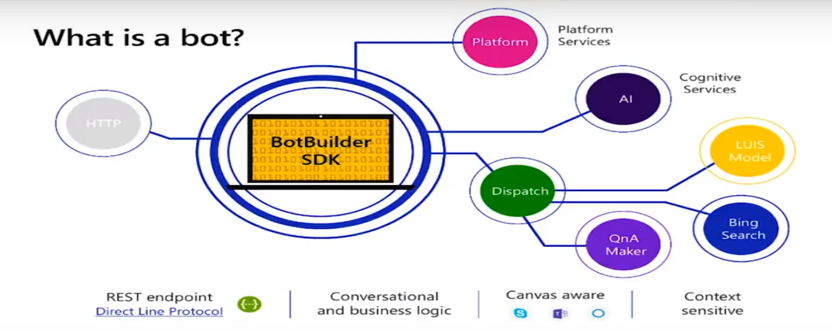

Figure Bot Architecture

As shown in the below diagram, Bot have multiple channels through which it can talk to users (Ex: Skype Channel)

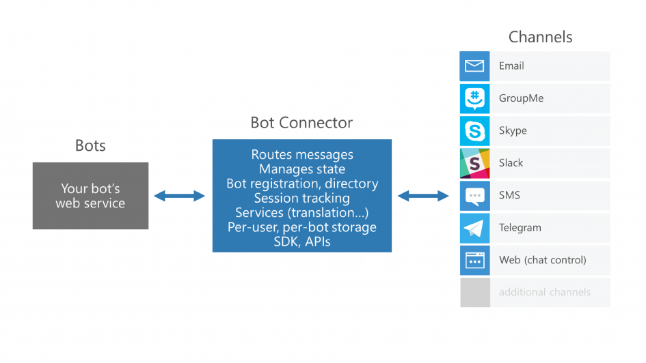

Figure 2 Bot Flow Diagram

|  |  |  |
| --- | --- | --- |
| **Bot Builder SDK** | **Azure Bot Service** | **Channels** |
| Build and connect intelligent bots | Accelerate Development | Connect your bot to Team, Skype, Cortana and other channels |
| Powerful, easy-to-ues frame work | Give your bot intelligence with Cognitive Services | Configure Channels via Azure Bot Service |
| Open source GitHub and Samples | Engage your user wherever they are (Cloud) | User Discovery Bots |

# Prerequisites for Development

|  |  |
| --- | --- |
| **Tools** | **Description** |
| Visual Studio 2017 | IDE for Development using C# or Node.js |
| Bot Builder SDK v4 template for C# | Project Template |
| Bot Framework Emulator | Testing Bot Locally using Emulator |

# Building Intelligent Bots with LUIS

## What is LUIS (Language Understanding Intergration Service)?

Language Understanding (LUIS) is a cloud-based API service that applies custom machine-learning intelligence to a user's conversational, natural language text to predict overall meaning, and pull out relevant, detailed information.

A client application for LUIS is any conversational application that communicates with a user in natural language to complete a task. Examples of client applications include social media apps, chat bots, and speech-enabled desktop applications.

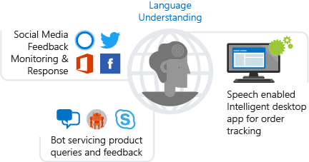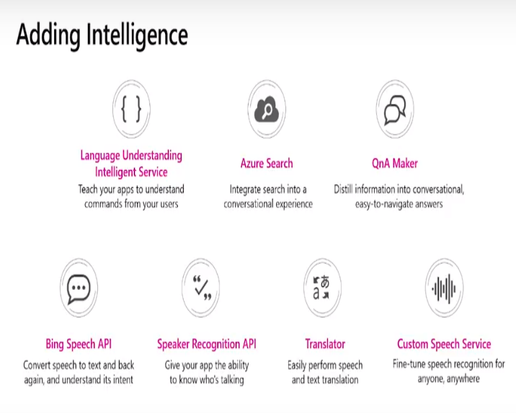

# Use Case (Bank TeleMarketing AzureML WebAPI)

### Objective : To predict whether client subscribe to the product or not

### Dataset



### Develop Machine Learning Module in AzureML studio with **Two Class Boosted Decision Tree**.

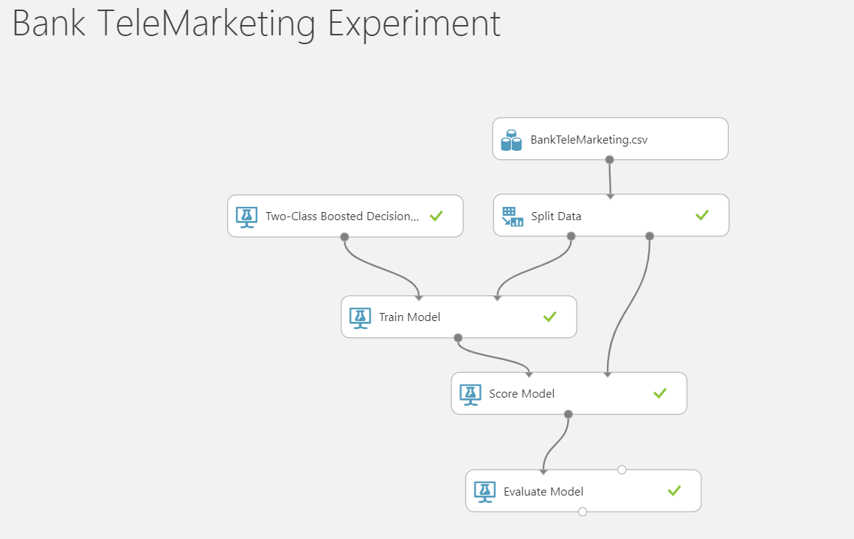

### Expose Web Service to consume the Model.

<https://ussouthcentral.services.azureml.net/workspaces/1a28f050ac0b4f3293b7655ee1206187/services/121d97ba7d334a57bf7e58d6bb6e57d5/execute?api-version=2.0&details=true>

### Develop Chat Bot in using Bot Builder SDK in C#.

LUIS would be tought with the below **utterances** for the **Intent** BankTeleMarketing.

